

Master MLDM, AIMA and 3DMT - Computer Vision course

_________________________________________

Exam March 2021 - 2h30 without documents

__________________________________________

(6 parts with a total of 17 questions accounting for 29 points, the exam will be scored for 25 points)

Part 1 (5 points - 15 mns): Triangulation

Two cameras are looking at the same scene. The projection matrices of the two cameras are P1 and P2. They see the same 3D point X = (X; Y; Z)^{T}. The observed coordinates for the projections of point X are x1 and x2 in the two images, respectively. The numerical values are as follows:
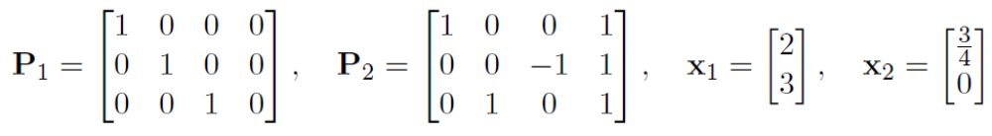

Question 1 (1 point): Compute the 3D coordinates of the point X. (Hint: Perhaps the simplest way in this case is to write the projection equations in homogeneous coordinates by explicitly writing out the unknown scale factors, and to solve X; Y; Z and the scale factors directly from those equations.)

Ans:
As s₁ x₁ = P₁ X we get s₁ X = 2 (1); s₁ Y = 3 (2) and s₁Z=1 (3)
As s₂ x₂ = P₂ X we get s₂ (X+1) = ¾ (4); s₂ (-Z+1) = 0 (5) and s₂ (Y+1)=1 (6)

We have 6 equations with 5 unknowns, after eliminating Y and Z we obtain s2/s1=1/4, after eliminating X we obtain s2=1/4.
So X=2; Y=3; Z=1 ; s1= 1; s2 = 1/4.

Question 2 (2 points): Present a derivation for the linear triangulation method and explain how X can be solved using that approach in the general case (i.e. no need to compute with numbers in this subtask).

Ans: thanks to the epipolar constraint we have another set of equations
x₁ = P₁ X and x₂ = P₂ X (2+1 equations for each corresponding points)
x₂^{T} F x₁ = 0 (with rectified image the search space is reduced to 1 dimension)
with a correlation method another equation can be defined to solve X

Question 3 (1 point): A third camera P3 is added to the scene. Describe how the linear triangulation method above can be extended to use the information from all the three
cameras.

Ans: See the process described in Part 1 of TD3_Computer_Vision_2021

Question 4 (1 point): If there is noise (i.e. measurement errors) in the observed image coordinates of point X, the linear triangulation method above is not the optimal choice but a nonlinear approach can be used instead. What error function is typically minimized in the nonlinear approach?

The correlation method is an example of nonlinear approach. One error function consists to minimize local incoherencies related to the depth estimation through a local smoothing criterion such as the one illustrated below:

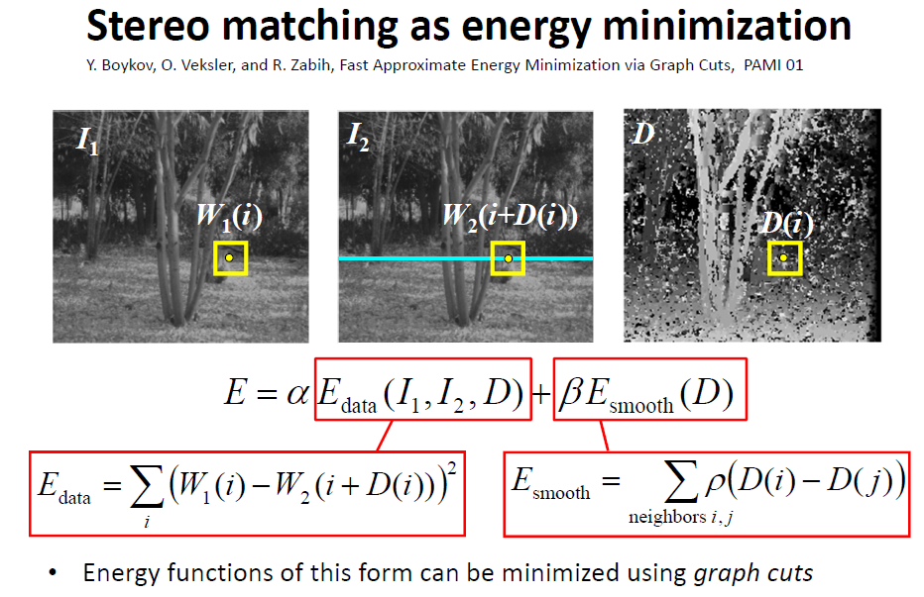

Part 2 (6 points - 30 mns): Geometric transformations

A rectangle with corners A = (0; 2), B = (3; 2), C = (3; 0), D = (0; 0) is transformed by a transformation T so that the new corners are A‘ = (-9; 0), B‘ = (-9; 6), C‘ = (-1; 6), D‘ = (-1; 0).

Question 1 (2 points): Assume T is a similarity transformation (i.e. rotation, scaling, translation). Solve the transformation using the corresponding corners (A; A‘) and (B; B‘). (Hint: Drawing a picture may be helpful for checking the result.)

Ans
B’
C’

A
90°
B

A’
C

A’ = T A

-9 |  | s cos θ | -s sin θ | t1 | 0
0 | = | s sin θ | s cos θ | t2 | 2
1 |  | 0 | 0 | 1 | 1

Likewise for B’ = T B

From these equations we can infer that s sin θ = 2 and that s cos θ = 0. So θ =90° and s=2. t1 = -5 and t2=0.

Question 2 (2 points): Describe the least-squares method for solving an affine transformation from n pairs of corresponding points.

Answer:

x = T X

x |  | s cos θ | -s sin θ | t1 | X
y | = | s sin θ | s cos θ | t2 | Y
1 |  | 0 | 0 | 1 | Z

We want to minimize ||Ψµ|| subject to ||µ|| = 1.
With µ = (s cos θ, -s sin θ, t1, s sin θ, s cos θ, t2, 0, 0, 1) (See slide 17 of Lecture 5). Ψ correspond to the number of known parameters (n corresponding points).

Thus, we use SVD on Ψ and obtain the eigenvector corresponding to the smallest eigenvalue to give us a scaled version of (s cos θ, -s sin θ, t1, s sin θ, s cos θ, t2, 0, 0, 1). (See slide 22 of Lecture 5).

Question 3 (1 point): Assume that T is an affine transformation. Solve the transformation using all four corners of the rectangles. (Hint: You may also use the picture to infer or check the result.)

Ans
C’
B’

A
90°
B

A’
C

A’ = T A

-9 |  | a1 | a2 | t1 | 0
0 | = | a3 | a4 | t2 | 2
1 |  | 0 | 0 | 1 | 1

Likewise for B’ = T B, C’ = T C, D’ = T D

From these equations we can infer that t1 = -1 and t2 = 0 (from D); a1 =0 and a3 = 2 (from C); a2 = -4 (from A) and lastly a4=0 (from B).

Question 4 (1 point): How many point correspondences are sufficient for determining an affine transformation in the general case? Justify your answer.

Ans: a 2D affine transformation is defined by 6 DOF, so 3 pairs of corresponding points are enough so solve this transformation (with 2 equations per pair). A 3D affine transformation is defined by 12 DOF, so 6 pairs of corresponding points are enough so solve this transformation (with 2 equations per pair).

Part 3 (5 points - 20 mns): Epipolar geometry and stereo
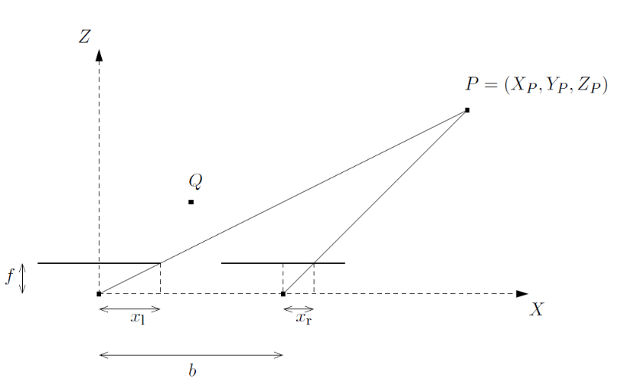
Figure 1: Top view of a stereo pair where two pinhole cameras are placed side by side.

Question 1 (1 point): Figure 1 presents a stereo system with two parallel pinhole cameras separated by a baseline b so that the centers of the cameras are cl = (0; 0; 0) and cr = (b; 0; 0). Both cameras have the same focal length f. The point P is located in front of the cameras and its disparity d is the distance between corresponding image points, i.e., d = |xl -xr|. Assume that d = 1 cm, b = 6 cm and f = 1 cm. Compute ZP.

Ans: Zp = f b/d = 6 cm (See slide 36 of Lecture 5)

Question 2 (2 points): Let's denote the camera projection matrices of two cameras by P =[I|0] and P’ =[R|t], where R is a rotation matrix and t = (t1; t2; t3)^{T} describes the translation between the cameras. Show that the epipolar constraint for corresponding image points x and x’ can be written in the form x’ ^{T} E x = 0, where matrix E is the essential matrix E = [t]_{x} R and [t]_{x} is the skew matrix corresponding to t.

Ans : E x define the epipolar line l’ corresponding to the point x. The corresponding projection x’ is necessarily on this line defined by E x. Consequently x’^{T} l’ =0, i.e. x’ ^{T} E x = 0

Question 3 (2 points): In the configuration illustrated in Figure 1 the camera matrices are P=[I|0] and P’=[I|t], where I is the identity matrix and t = (-6; 0; 0)^{T}. The point Q has coordinates (3; 0; 3). Compute the image of Q on the image plane of the camera on the left and the corresponding epipolar line on the image plane of the camera on the right. (Hint: The epipolar line is computed using the essential matrix.)

Ans: x_{Q}= f X_{Q}/Z_{Q} (pinhole model) so x_{Q}= 1 cm. Meanwhile y_{Q}= 0 cm
l’_{Q} is defined by :

 | 0 | 0 | 0 |  | 1 | 0 | 0 |  | 1 |  | 0
E x_{Q} = | 0 | 0 | 6 |  | 0 | 1 | 0 |  | 0 | = | 6
 | 0 | -6 | 0 |  | 0 | 0 | 1 |  | 1 |  | 0

as t = (6; 0; 0)^{T} and R = I

Part 4 (4 points - 15 mns): Multiple view constraints with lines

We assume n cameras in space, of calibration matrix Ki, oriented with rotation Ri and translation Ti with respect to some world coordinate frame.

Question 1 (2 points): Show that in general, the observation of a projection of a 3D line in a camera does not impose any constraint on its projection in another view.

Ans:
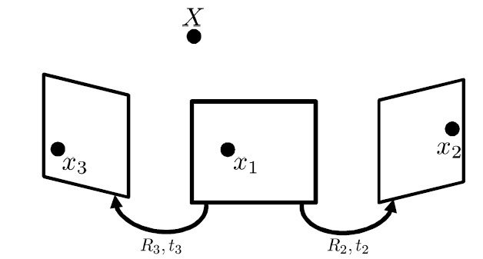

Question 2 (1 point): What is the exception?

Ans: When the projected points on one image (here the left one) overlap, in this case the corresponding projections on the centered image are located on the corresponding epipolar line, likewise for the right image (epipolar constraint).

Question 3 (1 point): By a simple geometric consideration, show that the observation of the projections of a 3D line in two views determines the projection in a third view.

Ans:

E12 = [T₁₂] x R₁₂, E13 = [T₁₃] x R₁₃, E₂₃ = [T₂₃] x R₂₃.

We know that the point x₁ corresponding to x₃ is on the corresponding epipolar line specified by E₁₃ x₁. We also know that x₂ is on the corresponding epipolar line specified by E₁₂ x₁.

We also know that the point x₂ corresponding to x₃ is on the corresponding epipolar line specified by E₂₃ x₃. So x₂ is on the intersection of epipolar lines specified by E₂₃ x₃ and E₁₂ x_{1.}

Part 5 (3 points - 15 mns): Feature detection and matching

Question 1 (1 point): Does the Harris Corner detector detect the same points in an image and its rotated version? Discuss and explain why.

Ans: The Harris Corner detector is invariant to rotation
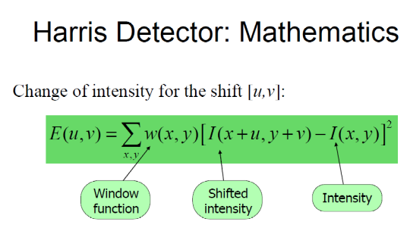
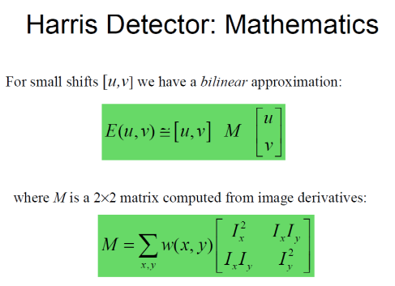
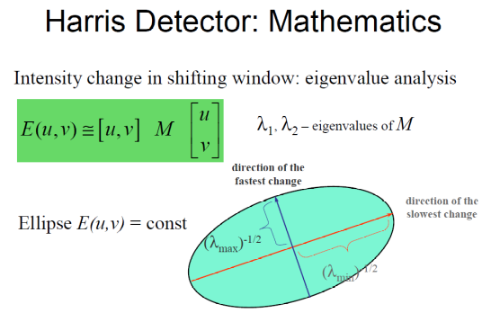
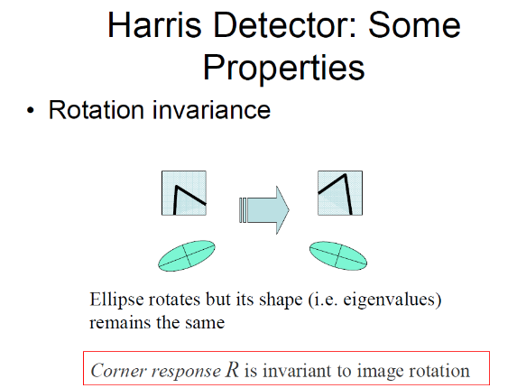

Question 2 (2 points): One possible issue when trying to match images are repetitive elements, that can be found at multiple locations in the image and generate ambiguous matches. Describe a simple strategy to remove these ambiguous matches.

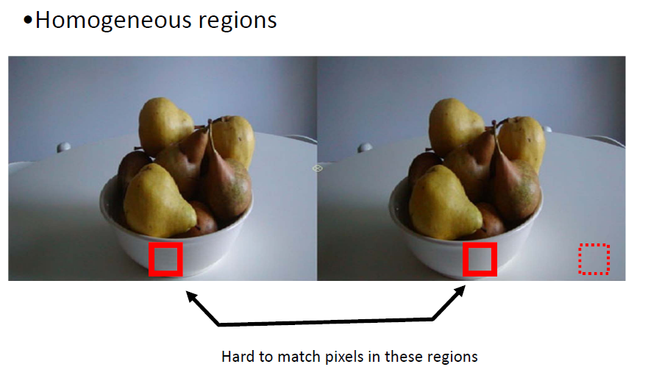
Higher contrast from Hight contrast from
“blacker” to “whitish” “blacker” to “whitish”

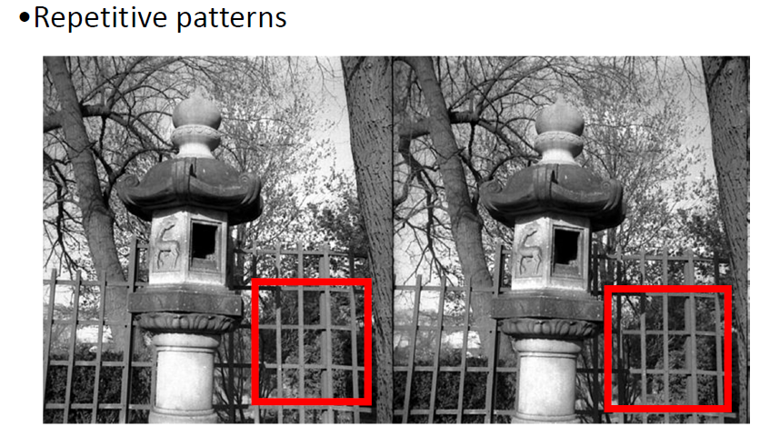
High contrast from Hight contrast from
black to white white to black

Thanks to epipolar geometry we can reduce the search space to one dimension. If images are rectified epipolar lines are aligned. If we are able to extract 2 corresponding key points on left and right images we can estimate the linear transform that relies coordinates in left and right images.

Part 6 (6 points - 30 mns): Feature detection and matching

Question 1 (6 points): A moving camera is taking pictures of three scenes: a 3D scene (Scene 1), a planar scene (Scene2), and a scene that is very distant from the camera (Scene 3). For each one of those scenes and each one of the following camera motions, explain whether the essential matrix can be computed. If not explain why. If it can be computed, describe the geometric arrangement of the epipolar lines. Provide a separate answer for each one of the above scenes and each camera motion below. (Hint: Drawing a picture with two camera positions may be helpful.)
- (Motion 1) A camera translating parallel to the image plane.
- (Motion 2) A camera translating forward.
- (Motion 3) A camera rotating around its optical axis.

Ans : for scene 2 (or scene 1) / motion 1

Optical
Axis

aligment of epipolar lines
C1 C2 C3

The epipolar constraint limits the search space to 1 dimension (here images don’t need to be rectified). Epipolar lines are defined by the essential matrixes:

E₁₂ = [t₁₂] x R₁₂, E₁₃ = [t₁₃] x R₁₃, E₂₃ = [t₂₃] x R₂₃. With R_{ij} = I

For scene 3 any small estimation error on the disparity will induce a high estimation error on the depth.

Ans : for scene 2 (or scene 1) / motion 2

Optical
Axis

corresponding epipolar line to Image 1
C3

corresponding epipolar line to Image 1

C2

C1

As we decrease the depth to the scene the size in Image planes increase (pinhole law).

The epipole points are inside the Images planes. On each Image plane the epipolar lines are intersecting on the epipolar point. Epipolar lines are defined by the essential matrixes:

E₁₂ = [t₁₂] x R₁₂, E₁₃ = [t₁₃] x R₁₃, E₂₃ = [t₂₃] x R₂₃. With R_{ij} = I and t_{x}=0, t_{y}=0.

For scene 3 as the depth is very high the x coordinate is very close in each Image (the disparity is very low).

Ans : for scene 2 (or scene 1) / motion 3

Optical
Axis

C3

C2

C1

No translation between images so [t_{ij}] x R_{ij} = 0_{3x3}
We cannot compute the essential matrix. All cameras have the same optical center (no baseline between optical centers).

Annex

The main steps of the Harris corner detector are:
- Compute the image derivatives Ix and Iy by convolving the image I with the derivatives of a Gaussian filter g(x; y).
- Form the Harris matrix
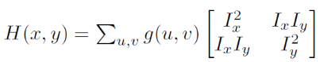

- Select points such that the Harris operator K(x; y) = det(H)= trace(H) is above a threshold K(x;y)>k.
- Perform non-maximum suppression

